HAWTHORNE
The State of Missouri Newsletter

SEPTEMBER 2020 ISSUE

Hawthorne Information

Hello Sisters! Well – here we are again – ready with the second issue of the 2020-2021 Hawthorne. I’m hoping my fellow members as well as chapters will send me info of how you are personally keeping busy while staying safe – recipes, projects and book titles or reviews you would recommend. I need your input to make our Hawthorne a success! Below are the deadlines for our future issues.

Winter Issue 2020
Articles/information to me by Saturday, November 14, 2020
The Hawthorne will be online and in the mail no later than Friday,
December 4, 2020

Spring Issue 2021
Articles/information to me by Saturday, February 13, 2021
The Hawthorne will be online and in the mail no later than Friday,
March 5, 2021

Summer Issue 2021
Articles/ information to me by Saturday, May 15, 2021
The Hawthorne will be online and in the mail no later than Friday,
June 11, 2021

If you have any problems with dates – please email or call me ASAP. If you have members that must have a mailed copy – please provide me with their full names and addresses – So far I have only four names.

I will acknowledge all articles/information sent to me as the items are received to avoid any miscommunications or worry. Thank you for your help and let’s start communicating!

Paula Miller
4995 E. Eagle Ridge Rd.
Columbia, MO. 65201
E-mail: maggiemoo1949@outlook.com
Telephone - (Cell) – (573) 819-0359

Making Covid-19 Work to My Advantage
Due to being homebound many of us are finding projects to keep busy and stay productive. Sooo - I decided this was the time to sort through about 25 storage tubs that have been stored in my storm shelter. I told my husband if there is a storm the only living creatures that would fit in the shelter have four legs and weigh about 14 pounds each and that would be Abby and Angus – our four legged furry kids.
As to the 25 storage tubs - well many years ago my Mother passed without a will and my brother whom those of you who know me - know that I refer to him as Bobble Head 2 decided he should get the good stuff and I should take the many card board boxes from her storage room. I could not just toss them into the trash because who knows – you might find a real treasure as a lot of the items were items I left at my Mother’s house when I left home many years ago.
So at that time I bought plastic storage tubs to get rid of the cardboard and promptly transferred items from the boxes to the tubs and did not bother to look at what I was transferring.
I went through the first tub a few months before Covid and what fun – I found jewelry that I wore in the 60s and am now wearing those items again.
So fast forward to Covid – decided it was time to sort, keep, toss, donate, give to the family or whatever was going to happen to these items and at the same time I decided to catalog each tub so it would be evident what is in each. My oldest Grandson refers to this project as “The Smithsonian Project” – which is very fitting.
I also found clothes that I wore in the 60s and before you ask - no I am not wearing those items but not because I would not want to!!!! – Get it? Actually found the outfit I wore to a demonstration which took place on Main Street south of the Plaza. Might mention some went to jail but because of a long tall motorcycle cop by the name of Arnie, I avoided jail time (another story for another time).
Imagine my surprise when I found the letter that I wrote to Don – my boyfriend when I was a senior in high school. I wrote to him telling him we needed to breakup. However, he wrote back to me on the back side of the same letter telling me why we should stay together. Needless to say we broke up. I told my Grandsons about this and they say that would be like texting someone today to breakup.
Also found so many items that were made by my three wonderful Grandsons and given to me and my husband. One of the items the three made was a poster that said “Nonni you are very sweat” assume they meant sweet. Bittersweet to see all of these items from them now that they are three wonderful young men.
So my advice to you is – if you have a project like this – go for it – it can be entertaining, a bit sad at times but do not let Covid keep you from being productive.

Jan Ross
MSC State President
2020-2021

Hi All,

I hope everyone is well and wearing masks. We have had some scares at the office with several folks testing positive. We have now closed the office for a while and are working remotely.

During the Pandemic, I have learned a lot about myself. Being home more has really given me time to reflect:
1) Elastic is my friend and a very important component in my work from home attire. And, when we go back to work in the office I think we should have at least one "come as you are in your PJ's day".
2) I need social interaction!! I need to see and talk to people. Jerry is of few words and dogs don't talk. So, I talk to myself constantly.
3) Wearing a mask is important but you can't see someone smile. I have been working on eye movements that might help people know I am smiling but with little success. In the meantime I am wearing a smiling mask. And, I think it makes me look younger...HaHaHa!
4) I need order and don't do well with clutter. That has proven to be a valuable trait since we have moved. We were unpacked in record time!
5) I have to finish a task before going on to the next. As we were packing to prepare for the move, I had to finish one room before moving on to the next or I would get overwhelmed. Now Jerry on the other hand, had about 12 things going on at one time....needless to say he was almost pushing up daisies in the backyard. Little did he know his life was in danger.
6) Finally, a glass of wine a day will keep the virus away... I just really hope so!!

Stay safe and ESA Hugs to all!

Brenda Fields
MSC President-Elect
2020-2021

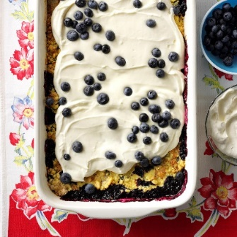

Lemon Berry Dump Cake

From Taste of Home

This sweet-tart cake recipe is so much fun to make with my grandkids. They love just "dumping it all in" and watching it magically become a pretty, delicious dessert. —Nancy Heishman, Las Vegas, Nevada

TOTAL TIME: Prep: 10 min. Bake: 45 min. + cooling
YIELD: 15 servings (3 cups lemon topping).

Ingredients
- 6 cups fresh or frozen blueberries
- 1 teaspoon ground cinnamon
- 3/4 cup butter, melted
- 1 package lemon cake mix (regular size)
- TOPPING:
- 2 containers (6 ounces each) lemon yogurt
- 1 container (8 ounces) frozen whipped topping, thawed
- 1/2 cup marshmallow creme
- 1/3 cup lemon curd
- Additional blueberries, optional

Directions
- 1. Preheat oven to 350°. Toss blueberries with cinnamon; spread into a greased 13x9-in. baking dish. Drizzle with half of the melted butter. Sprinkle with cake mix; drizzle with remaining butter.
- 2. Bake until golden brown and fruit is bubbly, 45-55 minutes. Cool on a wire rack.
- 3. Beat together yogurt, whipped topping, marshmallow creme and lemon curd. Serve dump cake with yogurt mixture and, if desired, additional blueberries.
Foundation News

I am very excited to take on the new role as MSC Foundation Counselor. Following Sally Yates, after 8 years of service as Foundation Counselor, is an intimidating task but she has already been extremely helpful and will continue to share her knowledge and experience.

As an incentive for new Foundation memberships during the 2019-2020 year, each state would be given $100 for every two new memberships. Missouri had four new memberships and so was given $200.00. As Foundation Counselor, Sally used that incentive money to provide the chapters in Missouri who were not members of the Foundation with the $25.00 initial membership fee as well as additional funds to provide a membership to a chapter member. Thank you, Sally. Now every chapter in Missouri will be a Foundation member.

The 2020-2021 Scholarship year has begun! Those looking for scholarships can create an online account, receive notifications for application deadlines and access details of all the available scholarships. ESA Foundation offers more than 200 scholarships each year. An average of 800 students apply for one or more scholarships and approximately $248,000 is distributed each year. Sadly, there were scholarships that did not receive any applications last year so there were funds available that were not given. Spread the word to your family, friends, neighbors and community to check out the many scholarship opportunities available through the ESA Foundation.

Even though the coronavirus is keeping us at home and away from most of our social activities we can still have fun, interact with each other and contribute to the ESA Foundation at the same time! There will be a virtual Fund Fest Murder Mystery event to benefit the Foundation on October 17 at 6:30 pm Central Time. More details are coming soon and I will send them to all the chapter presidents to share with everyone.

Sharon George
MSC Foundation Counselor
2020-2021

Book Leaves Wreath

BRIAN WOODCOCK listed in Country Living.com

How fun is this paper wreath? Allow it to bring the spirit of fall right to your front door this year.
Make the wreath: Draw a 3-inch-wide maple leaf shape on a piece of cardboard and cut out to create a stencil. Trace on original pages (or, preferred, photocopied pages) of a vintage book—consider a fall-themed title or mystery novel—and cut out approximately 100 leaves with decorative scissors that have a "torn paper" edge. Attach book page leaves to maple leaves with hot glue. Attach layered leaves to a 16-inch wreath form with hot glue, layering and overlapping them as you go. Hang with burlap ribbon.

Celebrating Childhood Cancer Awareness Month with virtual

St. Jude Walk/Run - Memphis, Tennessee, Aug. 20, 2020

In celebration of Childhood Cancer Awareness Month, supporters of St. Jude Children’s Research Hospital® are lacing up their shoes to walk, run and fundraise at their own pace and distance in neighborhoods across the country for the annual St. Jude Walk/Run on Saturday, Sept. 26.
New this year: A St. Jude Walk/Run mobile app, available in the Apple app store and on Google Play, will provide a unique experience to participants that includes access to a virtual opening ceremony, tour St. Jude Children’s Research Hospital and engagement opportunities using augmented reality. While this is not a timed year, there will be the option to complete a 5K.
“Every year, the St. Jude Walk/Run has a unique way of uniting communities all across the United States. And while we’re used to participating in these amazing events elbow-to-elbow in large, diverse crowds, this year’s virtual St. Jude Walk/Run will be just as powerful because we anticipate it will unite even more people online from wherever they are to support St. Jude families,” said Richard C. Shadyac Jr., President and CEO of ALSAC, the fundraising and awareness organization for St. Jude Children’s Research Hospital. “No matter where we are, we can be inspired by the courage and resilience of St. Jude families. No matter where we are, we can be united by our promise to not stop until no child dies from cancer.”
St. Jude is leading the way the world understands, treats and defeats childhood cancer and other life-threatening diseases. Treatments invented at St. Jude have helped push the overall childhood cancer survival rate from 20 percent to more than 80 percent since it opened more than 50 years ago.
Funds raised through events like this help ensure families never receive a bill from St. Jude for treatment, travel, housing or food – because all a family should worry about is helping their child live.
Participants are encouraged to be creative when logging their miles while staying safe by following social distancing guidelines. Consider a sidewalk parade, footrace, obstacle-course challenge, matching St. Jude shirts or themed outfits with props. Also, connect with members of the St. Jude Run Club who are logging miles and minutes together using the fitness app Strava.
To register, make a donation or learn more about market-specific offerings, visit stjude.org/walk-run. Participants can share their favorite moments of the St. Jude Walk/Run on social media using the hashtags #forStJude and #StJudeWalkRun.
About St. Jude Children's Research Hospital
St. Jude Children’s Research Hospital is leading the way the world understands, treats and defeats childhood cancer and other life-threatening diseases. Its purpose is clear: Finding cures. Saving children. ® It is the only National Cancer Institute-designated Comprehensive Cancer Center devoted solely to children. Treatments invented at St. Jude have helped push the overall childhood cancer survival rate from 20 percent to more than 80 percent since the hospital opened more than 50 years ago. St. Jude won't stop until no child dies from cancer. St. Jude freely shares the discoveries it makes, and every child saved at St. Jude means doctors and scientists worldwide can use that knowledge to save thousands more children. Families never receive a bill from St. Jude for treatment, travel, housing or food – because all a family should worry about is helping their child live. Join the St. Jude mission by visiting stjude.org, liking St. Jude on Facebook, following St. Jude on Twitter, Instagram and TikTok, and subscribing to its YouTube channel.

Loaf Pan Cheesy Sausage Penne - Servings-4

From the Pillsbury Kitchens - Prep-30 minutes Total-1 Hr. 10 Min

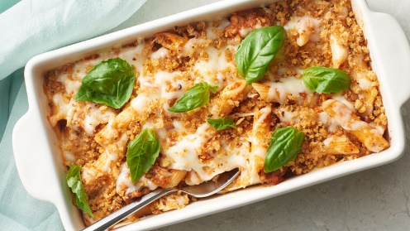

Ingredients

4 oz. uncooked penne pasta (1 1/4 cups)
1 tablespoon butter
¼ cup Progresso™ Panko Italian style crispy bread crumbs
¾ lb. bulk Italian pork sausage
¾ cup diced onions
1 ½ cups organic tomato basil pasta sauce (from 24.5-oz. jar)
1 ½ cups shredded mozzarella cheese (6 oz.)
Small fresh basil leaves, if desired

Directions
- Heat oven to 350°F. Spray 8x4-inch loaf pan with cooking spray. Cook and drain pasta as directed on package, using minimum cook time.
- Meanwhile, in 10-inch nonstick skillet, melt butter over medium heat. Add bread crumbs; cook 2 to 4 minutes, stirring frequently, until toasted. Pour into small bowl. Wipe out skillet.
- In same skillet over medium heat, add sausage and onions; cook 7 to 8 minutes, stirring occasionally, until sausage is no longer pink. Drain, if necessary.
- In large bowl, stir together sausage, sauce and 1 cup of the cheese. Add cooked pasta; toss gently. Spoon mixture into loaf pan. Top with remaining 1/2 cup cheese. Cover with foil.
- Bake 35 to 40 minutes or until thoroughly heated and cheese is melted. Top with toasted bread crumbs and basil.

Expert Tips
- If you can’t find bulk Italian sausage, you can use raw Italian sausage links. One (4-oz) link, removed from its casing, is a great substitution.
- Preparing the pasta al dente before adding to the pan ensures it won’t be overcooked after baking.
- We tested this recipe with mild Italian sausage, but if your family likes the heat, opt for spicy Italian sausage instead.
- Italian sausage varies in fat levels. If there is fat visible in the pan after browning, make sure you drain the meat before adding it to your casserole.

ALPHA OMEGA - Sally Yates
This is certainly a year to remember and you have heard this a thousand times. I hope you are safe and healthy along with your family and friends.
Alpha Omega held our first meeting since early March. We have had ZOOM time only each Tuesday to talk, laugh and catch up. Our meeting was the middle of August at Molly Vehige's home - brainstorming for what was to be the 2020-2021 plan for Alpha Omega. We were all masked, socially distanced, no food served and "bring your own drinks". It really was a fantastic meeting, with the year’s agenda looking great.
A few of the highlights. One was the presentation of our new Alpha Omega banner. We believed that after 20 years, the calico was out of vogue and had to be archived. Molly designed and she and Caretha Thomas quilted it together. Caretha designed a way to hold the banner in our hands so a pole is not needed, which we were always forgetting or losing anyway. Thank you Molly and Caretha, it is beautiful!
We are fortunate to have some funds from last year, as we have not been able to have any fundraisers. At the end of the year we normally give to several food pantries through The Turn Around Fund. The St. Louis Area Food Bank services 500 area pantries that we normally serve. They are able to purchase at cost and with donations say that each $1.00 donated will purchase four meals. We moved to give $500 to SLAFB through the TTAF. That is a Win/Win.
We are going to have a diaper drive for Nurses for Newborns and a Christmas Basket for Feed My People which we do every year. The one item that had to be addressed was Linda Owens’ garage and basement which has been full of garage sale items since April.
We will meet at Linda's on September 12th to sort clothes, appliances and kitchen utensils for Foster and Adoptive Care Families. The rest will be picked up by Care Coalition for infants through teens. Also Home Sweet Home is in great need of items which they will take where they believe it is most needed.
Miss everyone and hope we can get together in the near future. God bless and stay safe.

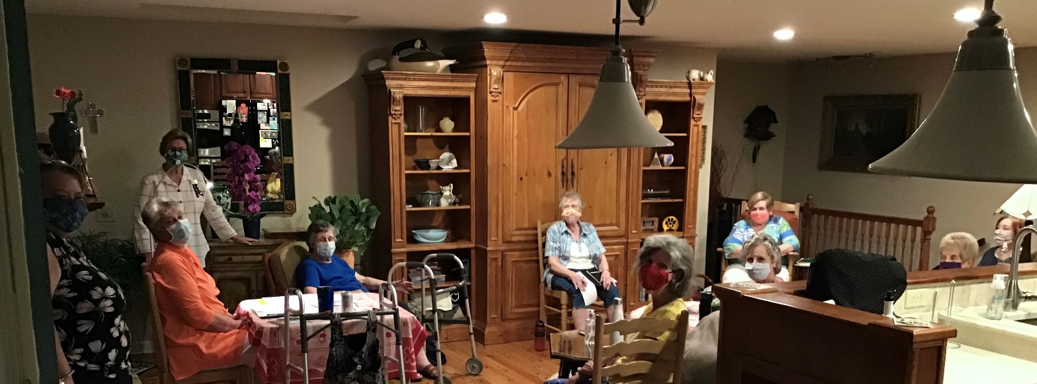

Just Some Dried Corn and Beans

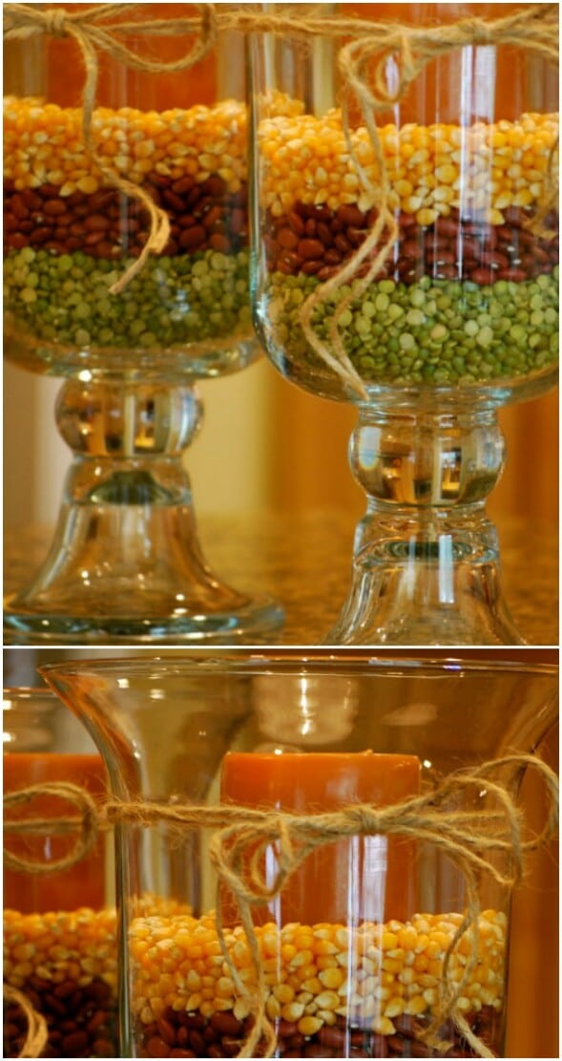

Some dried corn, beans, and peas make wonderful decorations for any candlestick. You’ll need a larger candle holder or use mason jars and then you just layer the dried foods around your candle. Tie a twine bow on it and it’s the perfect addition to your autumn décor.

Courtesy of Pinterest

Hello from COMO!

We hope everyone is staying healthy & safe, during these crazy times.
We held our installation via Zoom! Some of us lite our real candles, and others used, battery tea lights candles. We are now under the leadership, of Conne Burnham. A special ‘Thank You’ to Ann Heidy, for her leadership, the last two years!
Marcia Davis retired, and moved to NC this summer. She will remain an active member, we will miss her a lot.
Believe it or not, we have stayed busy. Unfortunately we had to cancel, the 4th annual ‘Strawberry Festival’, benefiting ‘Honor Flight’. Some of our sponsors and vendors, agreed to send their donation of $1,400.80 for this year! We held a social, at Serenity Valley Winery. Where the event would have been held. We were outside, spread out from each other. A great day of wine, music and laugher.
In June we had our ‘Plant Sale’, at Conne Burnham’s daughter’s home, only a couple of members worked. We raised $621.83 for our local ‘Food Bank’.
We are hoping to have our, 2nd annual ‘Pickleball Tournament’ later this fall, fingers crossed.
Until we meet again, be well!

Submitted by,
Karla Koskela
Gamma Eta

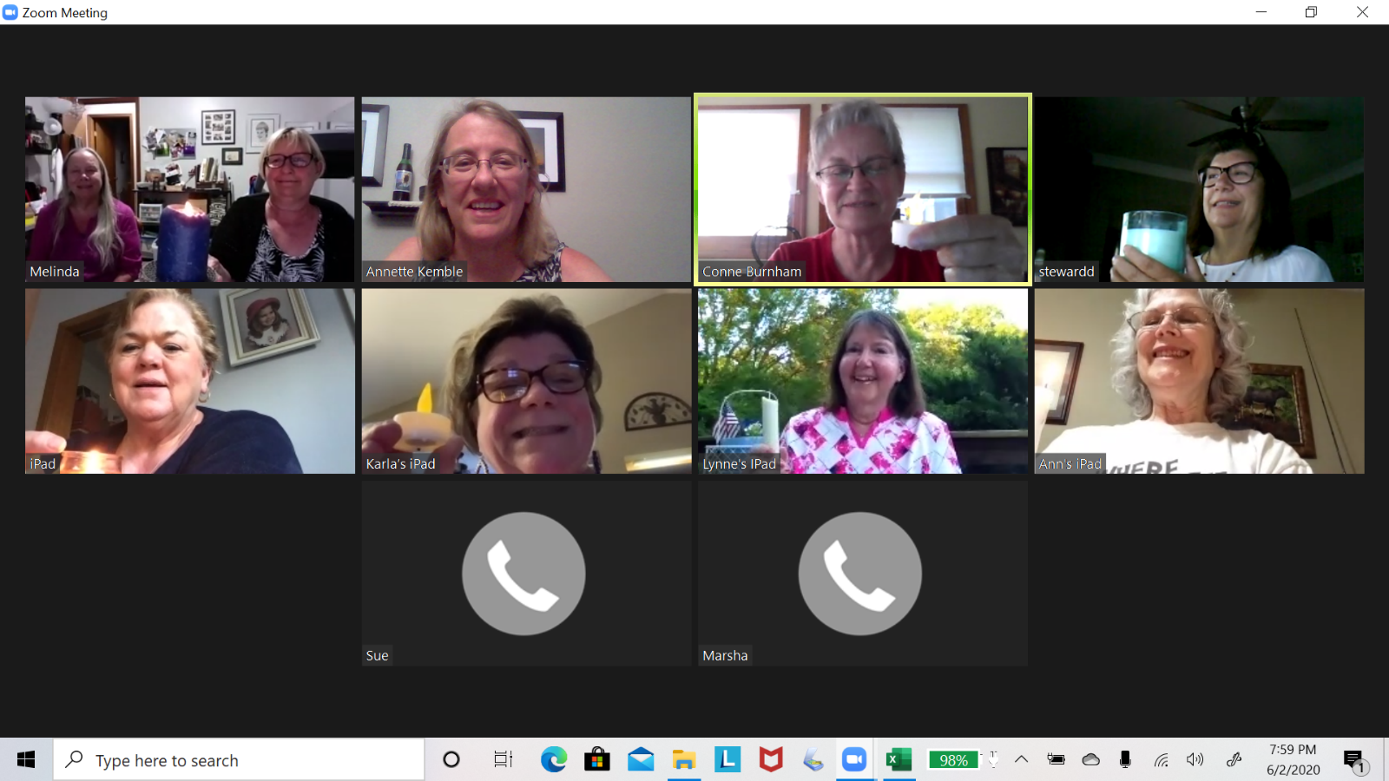

Let’s Stimulate Our Little Gray Cells

Advertising Campaign Primaries
The phrases below represent hypothetical early drafts of familiar commercial slogans, past and present. Your job is to figure out the familiar slogans clued by the phrases. Each phrase conveys the same basic message as the finished slogan, and the words in both versions have the same beginning letters. For example, the phrase “Ring operator, access telephone service” shares the sentiment of the finished phrase “Reach out and touch someone”, the classic slogan of AT&T.
- Sound cereal produces!
- Flavorful, leaking grease!
- Proprietor’s directive: “Spare toiletry cylinders!”
- Lad’s molars never cleaner!
- Great taste, though licking dregs
- Wednesday imperative: All packages hit town by Thursday! Okay?
- Iconic little tune tells TV watchers “Try soda”
- “Wow, tiny burger!”
- Inhibiting floor, an invalid calls guys urgency
Movie Sets
Listed below in each set are the titles of four films and your job is to figure out what they all have in common. For example, in the set “Blue Velvet,” “All of Me,” “Peggy Sue Got Married,” and “American Pie,” the common element is that all the film titles are also song titles. Keep an open mind when considering each set: a common bond could involve plot, characters, actors, wordplay in the title – almost anything.
1.”Rain Man,” “Diamonds are Forever,” “The Hangover,” “Ocean’s Eleven”
2.”Date Night,” A Clockwork Orange,” “What’s Eating Gilbert Grape,” “Pineapple
Express”
3.”Back to the Future Part II,” “Dr. Strangelove,” “Coming to America, “Austin
Powers: Goldmember”
4.”Pet Sematary,” “The Pursuit of Happyness,” “Boyz in the Hood,”
“Inglourious Bastards”
5.”Lord of the Flies,” Glengarry Glen Ross,” “The Great Escape,” “12 Angry Men”
6.”Where Eagles Dare,” “The Evil That Men Do,” “Something Wicked This Way Comes,” “To Be or Not to Be”
7.”The Shawshank Redemption,” “Maximum Overdrive,” “Hearts in Atlantis,” “Stand by Me”
8.”Sitting Pretty,” Alice Doesn’t Live Here Anymore,” “The Odd Couple,” ”M*A*S*H”
9.”The Color of Money,” “A Shot in the Dark,” “Dawn of the Dead,” “Analyze
That”

Answers can be found later in this issue!

September Hawthorne Article
Beta Tau Chapter, Columbia Missouri
Terri Breedlove Reporting

Hmmm 2020 started off with a bang. We had a new member Christy Fritschi who attended Winter Board in Columbia. We were looking forward to being one of the host chapters for MSC Convention. Then March hit us with the Coronavirus, we had an early March meeting and Christy pledged a new member Nita Abbott. Then the shutdown began. We were at a stay at home order for March and April.

In late May the new officers of Beta Tau installed were installed following brunch at the home of Barb Henke. The officers are as follows: President Barb Henke, Vice President Julie Whitaker, Treasure Patti Palmer, Recording Secretary Kathy Farmer and Parliamentarian, Terri Breedlove. The new Presidents Theme “Fields of Friendship thru ESA”. Terri installed the officer. We also had a pledge ceremony for Nita conducted by Julie.

Our St Jude Golf Classic was cancelled. We continue to try to touch base thru text messages. We are planning to have a Catalog Pampered Chef Party in September as our annual fundraiser for Easter Seals.

Please keep safe until we meet again.

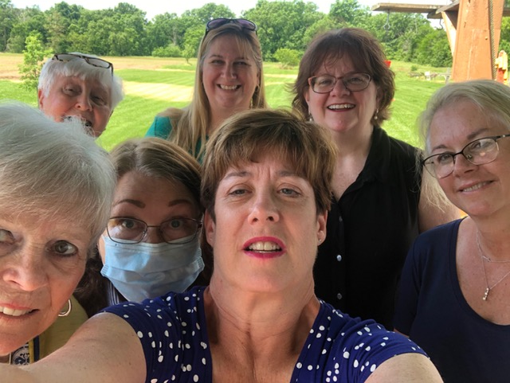

Dish Out Some Hospitality

MICHAEL PARTENIO from country living.com

Greet guests with this charming alternative to a fall wreath. Simply apply a layer of chalkboard paint to the inside of an old tray, then add autumn leaves and bittersweet berries for a seasonal finish. (Swap in evergreen and holly for the holidays.

BETA ETA HAWTHORNE ARTICLE – Sept. 1, 2020

IN SPITE of the Covid shut down, Beta Eta had our Annual Installation of Officers, on June 15th. Along with Sandy Hosack, Installing Officer, we six members met at the home of Linda Clarke and had a beautiful ceremony. Thank you Sandy for your inspiring work and lovely decorations. Our new president is Carol Huesemann, and her theme is ”KEEP CALM AND CARRY ON WITH CHOCOLATE, WINE, AND ESA” The theme was carried out by Sandy with small bottles of wine and chocolate bars for each of us. Yum – we may have a tasty year ahead.
Even though we haven’t had any get-togethers, our continuing work for charities includes cutting coupons, crocheting hats, scarves & blankets. Some attended the Zoom Convention – that was “different” to say the least. We will be getting back to meetings again in September, I think.
Meanwhile, stay SAFE, stay HEALTHY, and wear those masks. Hopefully we will eventually be “back to normal!”

Marty Neuman, Beta Eta Secretary

Delta Iota #2379…Jane Waterman, reporter
June and August found us cooking and delivering dinner for Crossroads. We did not serve due to COVID.
We had a lovely salad social/business meeting at the home of Jane Waterman in August.
We have celebrated several birthdays and anniversaries over the past 3 months: June birthday was Geri Nicholas, 6/5 and anniversaries were Jane Waterman, 6/4 and Dayle Mixer, 6/14. Karen Chatfield celebrated her anniversary 7/24. And Dayle celebrated her birthday, 8/13.
Unfortunately, we don’t have anything major planned for the near future…sigh. But, will be enjoying each other.
Editoral Thoughts from the Editor:
My Neighborhood Association recently had their annual meeting. To say, being at home, “stuck” with a spouse and children has taken its toil on what I considered “lovely” neighbors, is to say the least. They yelled, they growled, they interrupted each other and they even swore – the meeting turned into the Hatfields’ and the McCoys’ battleground! I was dumb founded – as I always thought, being a city girl, that living in the country would be the most wonderful thing in the world. Boy are my eyes open now!
While I was browsing the internet for tidbits for this issue of the Hawthorne I came upon the following item. I have started “mass production” of these little “cuties” and plan to distribute them in mailboxes with a note reminding people to be courteous and kind to their neighbors.

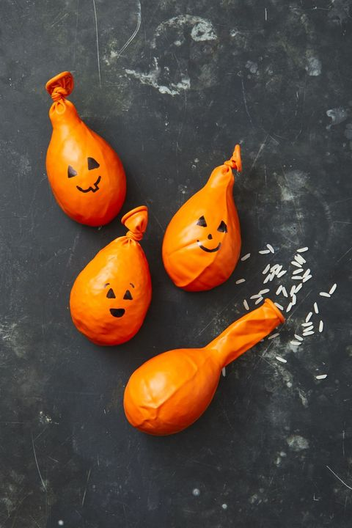

Pumpkin Stress Balls by MIKE GARTEN

Fill orange balloons with rice and draw on faces with a black Sharpie to create stress-relieving pumpkins. Both kids and parents will benefit from a squeeze or two.
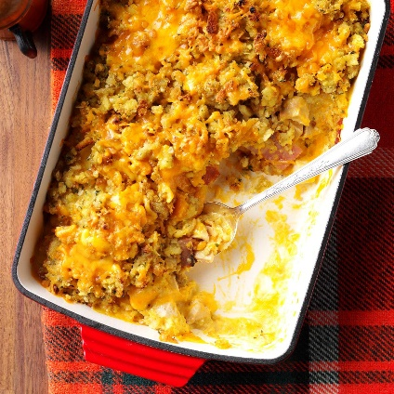

Chicken Cordon Bleu Bake from Taste of Home
I got this easy chicken cordon bleu recipe from a friend years ago. I freeze several half recipes in disposable pans to share with neighbors or for when I'm pressed for time myself. —Rea Newell, Decatur, Illinois

TOTAL TIME: Prep: 20 min. Bake: 40 min. YIELD: 2 casseroles (6 servings each).

Ingredients
- 2 packages (6 ounces each) reduced-sodium stuffing mix
- 1 can (10-3/4 ounces) condensed cream of chicken soup, undiluted
- 1 cup 2% milk
- 8 cups cubed cooked chicken
- 1/2 teaspoon pepper
- 3/4 pound sliced deli ham, cut into 1-inch strips
- 1 cup shredded Swiss cheese
- 3 cups shredded cheddar cheese

Directions
- 1. Preheat oven to 350°. Prepare stuffing mixes according to package directions. Meanwhile, whisk together soup and milk.
- 2. Toss chicken with pepper; divide between 2 greased 13x9-in. baking dishes. Layer with ham, Swiss cheese, 1 cup cheddar cheese, soup mixture and stuffing. Sprinkle with remaining cheddar cheese.
- 3. Bake, covered, 30 minutes. Uncover; bake until cheese is melted, 10-15 minutes.
Freeze option: Cover and freeze unbaked casseroles. To use, partially thaw in refrigerator overnight. Remove from refrigerator 30 minutes before baking. Preheat oven to 350°. Bake, covered, until heated through and a thermometer inserted in center reads 165°, about 45 minutes. Uncover; bake until cheese is melted, 10-15 minutes.
DEALING WITH THE PANDEMIC

Here is a poem from Elayne Clift of Saxtons River, Vt. (from The New Normal, NPR):
Courtesy of Kathie Hake
No make-up, manicures, or matching clothes,
Although I do miss the occasional massage.
No big-girl shoes, or ironed shirts, or bothersome bras.
No potluck pressure, or parties for which I “have prior plans,”
No cheek-to-cheek kisses, or unwanted hugs, although
One from a loved one would be grand.
No worries about my hair, or how I look,
Or for that matter, what I cook.
No deadlines to meet, I’m happy to say,
Except for an occasional library book,
Although, I confess, some compensation,
For a class or oration, would be
Cause for celebration.
When this nasty bug is over and gone,
It will occasion dance and song,
And I will welcome that of course.
But while enjoying its demise,
With good cheer and libation,
I have to admit, it’s likely that,
I will miss the liberations.

OR – there is this approach from our own Brenda Fields:

Little Gray Cell Answers

Advertising Campaign Primaries

- Snap! Crackle! Pop! (Rice Krispies)
- Finger lickin’ good! (KFC)
- “Please don’t squeeze the Charmin” (Charmin Toilet Tissue)
- Look, Ma, no cavities! (Crest Toothpaste)
- Good to the last drop! (Maxwell House Coffee)
- When it absolutely has to be there overnight (FedEx)
- “I’d like to Teach the World to Sing” (Coca-Cola)
- Where’s the beef? (Wendy’s)
- I’ve fallen and I can’t get up (Life Alert)

Movie Sets

- All have scenes in Las Vegas
- All titles contain the name of a fruit
- All feature an actor or actors playing numerous roles
- All titles contain misspellings
- All have exclusively male casts
- All titles are taken from Shakespeare
- All are based on Stephen King works
- All were later made into TV series (Sitting Pretty as “Mr. Belvedere,”
and Alice Doesn’t Live Here Anymore” as “Alice”)

And last but not least – 9. All are sequels

Puzzles courtesy of “Crowd-Pleasing Puzzles” by Patrick Berry and Todd McClary

Butter Pecan Pretzel Bars

From The Pillsbury Kitchen
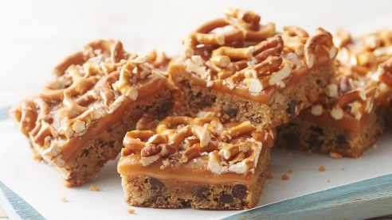

Ingredients

1 roll (16.5 oz.) Pillsbury™ refrigerated chocolate chip cookies

¾ cup chopped toasted pecans

1 bag (11 oz.) caramels, unwrapped

2 tablespoons milk

1 cup broken tiny pretzel twists (about 40 twists)

1/4 teaspoon kosher (coarse) salt

Steps
- 1. Heat oven to 350°F.
- 2. In medium bowl, crumble cookie dough; stir or knead in 1/2 cup of the pecans until well mixed. Press evenly in ungreased 9-inch square pan.
- 3. Bake 18 to 22 minutes or until deep golden brown. Cool 30 minutes.
- 4. In medium microwavable bowl, microwave caramels and milk uncovered on High 2 to 3 minutes, stirring every 60 seconds, until melted and smooth. Pour evenly over bar. Sprinkle with pretzels and remaining 1/4 cup pecans, pressing slightly into caramel. Sprinkle with salt. Cool about 1 hour 30 minutes or until caramel is set. For bars, cut into 4 rows by 4 rows. Store covered in refrigerator.

Prep – 20 minutes
Total time – 2 hours 45 minutes
Ingredients – 6
Servings - 16

COVID-19 alert
Coronavirus Disease

COVID-19 affects different people in different ways. Infected people have had a wide range of symptoms reported – from mild symptoms to severe illness.

Symptoms may appear 2-14 days after exposure to the virus. People with these symptoms may have COVID-19:

Fever or chills
Cough
Shortness of breath or difficulty breathing
Fatigue
Muscle or body aches
Headache
New loss of taste or smell
Sore throat
Congestion or runny nose
Nausea or vomiting
Diarrhea

Look for emergency warning signs for COVID-19. If someone is showing any of these signs, seek emergency medical care immediately:
Trouble breathing
Persistent pain or pressure in the chest
New confusion
Inability to wake or stay awake
Bluish lips or face

Call your medical provider for any other symptoms that are severe
or concerning to you.
Have a Happy Halloween and a Great Thanksgiving!

Don’t forget to submit articles, pictures and items you’d like to see in the Winter Issue of the Hawthorne by November 14, 2020.

