HAWTHORNE
The State of Missouri Newsletter

NOVEMBER 2020 ISSUE

Hawthorne Information

Hello Sisters! Well – I’m back again – ready with the third (winter) issue of the 2020-2021 Hawthorne. I’m still hoping chapter members will send me info of how you are keeping busy while staying safe – recipes, projects, book titles or reviews you would recommend. I need your input to make our Hawthorne a success! Below are the deadlines for our future issues.

Spring Issue 2021
Articles/information to me by Saturday, February 13, 2021
The Hawthorne will be online and in the mail no later than Saturday,
February 27, 2021

Summer Issue 2021
Articles/ information to me by Saturday, May 15, 2021
The Hawthorne will be online and in the mail no later than Saturday,
May 30, 2021

If you have any problems with dates – please email or call me ASAP. If you have members that must have a mailed copy – please provide me with their full names and addresses – So far I have only four names.

I will acknowledge all articles/information sent to me as the items are received to avoid any miscommunications or worry. Thank you for your help and let’s start communicating!

Paula Miller
4995 E. Eagle Ridge Rd.
Columbia, MO. 65201
E-mail: maggiemoo1949@outlook.com
Telephone - (Cell) – (573) 819-0359

Never Forget Who We Have Lost (COVID and Other Events)
I was recently talking with my three grandsons who are 28, 25 and 21 discussing COVID 19 and how it has had a major effect on the lives of all and the fact that they will be telling their kids how it affected them and their kids will learn about it in American History. They all three agreed this time in their lives would be etched in their memories for years to come as it has had such an effect on each of them in different ways. That brought up the subject of major events that I have seen during my lifetime and how my memory of each of them is so vivid. So they asked me to explain. Here are some what we discussed:
President Kennedy’s assassination - 11/22/63. My boss who was anti- President Kennedy came into the office and told us the President had been assassinated. He was always telling us “Kennedy jokes”. We told him he was not funny and then realized he was serious. We all went into the conference room and listened to the reports on the radio until the office closed for the day. P.S. I remember the outfit I was wearing that day.
Mt Saint Helens Eruption – 5/18/80 – I lived on Green Mountain in Seabeck, WA. It was Sunday and all of a sudden our two Great Danes (Dax and Reba) howled in a way I had never heard before even when wildlife ventured close to our yard. Our little mixed breed rescue (Houlio) started running around the house very agitated for no apparent reason. Shortly hereafter I felt the house shake and the dishes in the cabinet rattled. I turned on the TV and saw the volcano had erupted causing the loss of lives both human and animal. One survivor was an abandoned mother dog who crawled under a log jam and gave birth to 5 puppies. She and the puppies were rescued. Needless to say they were all adopted including the mother as soon as the puppies were weaned and able to be adopted.
Space Shuttle Challenger – 1/28/86 – I was living in Fort Collins, CO and at the office. My boss’s wife arrived and told us she had been told the shuttle exploded but she was confused and thought it was the shuttle from Fort Collins to the Denver airport. A very sad day for America and the Space Program.
Kansas City Missouri Firefighters Killed - 11/29/88 -The day the six Kansas City, Missouri Fire Fighters were killed by an explosion caused by a fire set in a trailer that held massive amounts of ammonium nitrate and fuel oil. The fire was set by six people as a diversion to allow them to steal contractor’s tools. All but one is serving a life sentence without the possibility of patrol. I had by then moved to Kansas City. We felt the blast and had minor damage to our patio. This was a hard time for Kansas City as the city was very protective of all first responders and these men were killed for doing their jobs and protecting the citizens.
Terrorists Attacks 9/11/2001 – I was at work when a co-worker came in and the look on her face was evident something awful had happened. We watched in horror the scenes that were televised. A number of us went to services at the Cathedral and then the office was closed for the day. This was the day the city ceased doing business and so many memorials were held for those who lost their lives including first responders who climbed 11 flights of stairs and probably knew they were climbing to their death to save others. Father Mychal Judge, beloved chaplain to the NYFD who was at the site giving last rites to fallen firefighters was killed when he was struck by fallen debris.
Jan Ross
MSC President
2020-2021

Delta Tau – Gloria VanDover

What a year we are having due to COVID. We had our spring plant sale and it was a success.
Joyce Henderson celebrated her ninety birthday and she received about one hundred cards, She is now living in an assisted living home, Cassie Taylor is also living in assisted living and Elsie Clarke can no longer drive. Mae Hudson is staying at home due to her cancer. Jan Sexton and I are the only ones who are able to drive.
What I have been doing to keep in touch with everyone is to make a phone call on our meeting days. I also send Halloween and Thanksgiving cards. I feel it is very important to keep in touch with everyone.
We are supporting our local food pantry, Circle of Concern, with gift cards this Christmas, as we are unable to shop for a family and play Santa by choosing certain gifts.
We wish everyone Happy Holidays and a safe New Year and look forward to the day when these masks will no longer be needed.

Hey Everyone!

This year is quickly coming to an end and not soon enough. I don't know about you but I had planned 2020 to be the best year ever and have been a bit disappointed (Ok, really disappointed) in how it has played out. I personally have had some ups and downs as we all have.
As I look back, I have decided it’s how we handle the ups and downs that really set the tone. Trying to find the sunshine on a cloudy day (I am getting a little sappy) can be hard but a real possibility. It's all about being resilient as we navigate through the difficult times.
So with all that said, I look at what we have been able to accomplish through the pandemic and all the other life challenges this year, we are a resilient group!! And, it will be so good to see everyone in person in the upcoming year.
With the Holidays upon us, I know our family has made a decision; we are not having a family gathering for Thanksgiving. We will make a decision in December about Christmas. So for Thanksgiving, it is just David and I. He thinks that sounds really nice and relaxing for a change. He has requested a regular Thanksgiving meal with lots of green bean casserole. I am going to make that happen!
I shared this in my RE-MARC article, Thanksgiving is actually my most favorite holiday. I think it is more about gathering with family, laughing and all of the stories we tell over and over each year. I cannot tell you how many years my Mom told the story of my first date. I will not bore you here with that story, it would be best told with an adult beverage.
I have so many funny memories from Thanksgiving growing up. My Dad was a really funny guy. He would do goofy things. After we moved out on our own, we could expect a call from Dad the morning of Thanksgiving and he would say, "Do you want to talk to Tom Turkey and we would of course say yes. We would then hear the oven door open and Tom Turkey would say. "Help Me, Help Me." It was so silly and I can't believe that I would even tell that. I do miss his silliness.
There was the time my Mom forgot to turn on the oven Thanksgiving morning. Dad didn't even notice when he made his silly calls to us. And, the entire family arrived and didn't even notice the missing aroma of a turkey cooking. We had leftover spaghetti that year and came back on Sunday for Turkey.
Finally, I just want to say, have a wonderful Holiday season! We have a lot to look forward to in the upcoming year and hopefully in person!! Take care and be safe!

Brenda Fields
MSC President-Elect
2020-2021
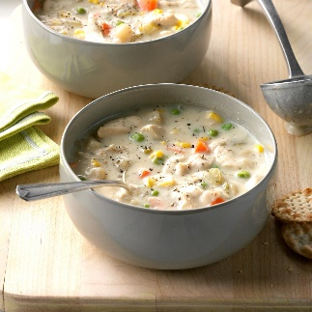

Chunky Creamy Chicken Soup

From Taste of Home
I am a stay-at-home mom who relies on my slow cooker for fast, nutritious meals with minimal cleanup and prep time. I knew this recipe was a hit when I didn't have any leftovers and my husband asked me to make it again. —Nancy Clow, Mallorytown, Ontario

TOTAL TIME: Prep: 15 min. Cook: 4-1/2 hours YIELD: 7 servings.

Ingredients
- 1-1/2 pounds boneless skinless chicken breasts, cut into 2-inch strips
- 2 teaspoons canola oil
- 2/3 cup finely chopped onion
- 2 medium carrots, chopped
- 2 celery ribs, chopped
- 1 cup frozen corn
- 2 cans (10-3/4 ounces each) condensed cream of potato soup, undiluted
- 1-1/2 cups chicken broth
- 1 teaspoon dill weed
- 1 cup frozen peas
- 1/2 cup half-and-half cream

Directions
- 1. In a large skillet over medium-high heat, brown chicken in oil. Transfer to a 5-qt. slow cooker; add the onion, carrots, celery and corn.
- 2. In a large bowl, whisk the soup, broth and dill until blended; stir into slow cooker. Cover and cook on low until chicken and vegetables are tender, about 4 hours.
- 3. Stir in peas and cream. Cover and cook until heated through, about 30 minutes longer.

FOUNDATION NEWS

The 2020-2021 school year is well under way and whether high school students are learning from home or are in the classroom, many are researching scholarships available to them. We are proud to say the ESA Foundation offers more than 50 scholarships to students who live in Missouri! Letters were sent to over 500 high school guidance counselors in Missouri with information about ESA, the Foundation and how their students can access the scholarship and grant details and complete their applications online. Remember to spread the word about the scholarships. The deadline for the applications is February 1, 2021.

It is time to pay annual Foundation dues. If you are a member, you should be receiving a reminder letter in early December. And if you are not (yet) this is a great time to join! Think of all the money you have not spent this year – no state meetings, no IC meeting and so many other activities that we have had to cancel. Initial membership fee is only $25.00 and annual dues are $15.00. Education has been greatly disrupted this year and students will need all the help they can find. The Foundation scholarship program is a win-win. You support the ESA Foundation Scholarship Program and help deserving students who will receive assistance to achieve their goals. This is a relatively small thing that makes a big difference! Please, send your dues as soon as possible. This will save headquarters the expense of mailing reminders. Our Foundation dues support and maintain the endowments and scholarships. Dues and donations are also tax deductible.

Another reminder – when you are planning your charitable donations to any charity, consider using the ESA Turnaround Fund. Here is a summary from Kim Mandrell of how the turnaround fund works and how it benefits the Foundation:
- Rather than sending individual checks to one or more 501-c3 charities, the individual sends one check to the Foundation indicating which charity is to receive what amount. The Foundation turns around this request and sends individual checks back to the person using the turnaround fund. Then the person sends the checks to the individual charities.
- Benefit: Easier to document donations on your taxes (donations to one charity instead of multiples)
- Item to remember: Checks are returned to the individual, not the charity, so the individual needs to send them on to the charity.
Kim, thank you for a clear and simple explanation of the turnaround fund!

Sharon George, Alpha Omega
Foundation Counselor

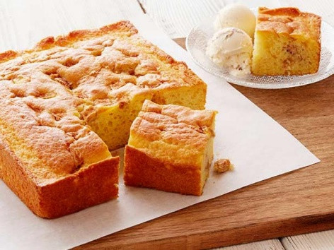

RECIPE COURTESY OF RACHAEL RAY AND MARIA BETAR

My Sister Maria's Easy Apple Cake and Ice Cream
- Total: 30 min
- Prep: 5 min
- Cook: 25 min
- Yield: 6 servings

Ingredients
1 box yellow cake mix for a single layer cake, (recommended: Jiffy brand) prepared to package directions
2 tablespoons softened butter
1 McIntosh apple, diced
1/2 teaspoon ground cinnamon
1/4 cup sugar
1 pint butter pecan or rum raisin ice cream

Directions
- Preheat oven to directions on box.
- Mix cake mix to directions on box, using 1/2 cup water and 1 egg.
- Grease a 9 by 9-inch square cake pan or disposable cake pan with butter.
- Pour in cake batter.
- Toss apples with cinnamon and sugar and sprinkle on top of cake batter.
- Bake 20 to 25 minutes.
- Serve warm cake squares with small scoops of butter pecan or rum raisin ice cream.
Alpha Omega – Linda Owens
It’s been a difficult year with all the issues with the Covid 19, but we are all surviving. We did meet at Molly Vehig's in August and we don't know when we will be able to meet again. We had a safe distancing meeting with every one being masked. Normally we change officers in April but obviously that didn't happen this year. The same officers will continue for this next year.
We continue with our same charitable donations and plans for this year. We continue to support Nurses for Newborns by assisting the new mothers with needed items for their babies and for themselves. We are meeting on November 16, 2020 to fill 100+ bags of lotions, soaps, deodorants, bath sponges, scrubbies, shampoo, combs, nail files, wash clothes, sanitary pads and diapers.
We will continue to provide a Christmas Basket of gift cards for Feed My People families in need. Typically we adopt one or two families and provide them with clothes, groceries and cleaning items. This year, Feed My People has requested only gift cards. We also assist with utility bills.
Because of Covid 19, none of us were able to work the Dream Homes this year. The builders themselves handled all the details and open houses.
We will not be having a typical Think Spring Luncheon, auction and Easter Eggs candy and prizes this year due to the Covid 19. But we are planning special packages to send to our regular guests to solicit donations for St. Jude. We are hoping to have a good result from our mailings.
Unfortunately, we will not be able to have our normal Christmas gatherings this year, but are looking forward to making up for lost time in 2021.
Below is a picture of our new banner which was made by Molly Vehige and Caretha Thomas. Really lovely.
Have a safe and happy 2020 Holiday Season.

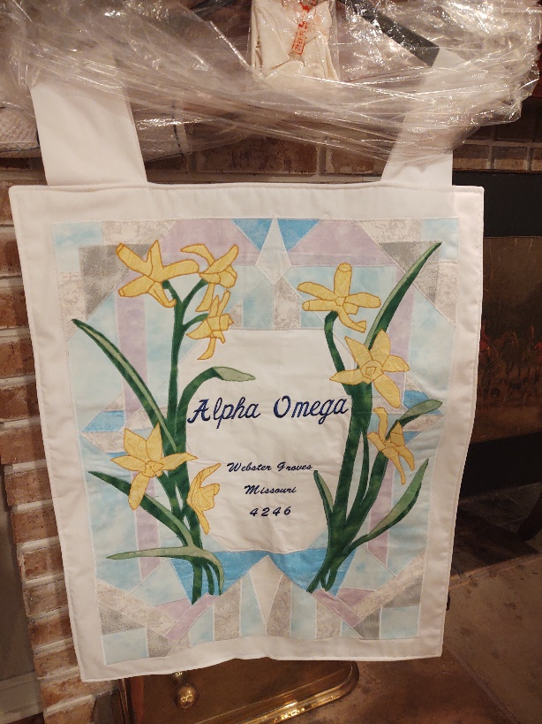

What is the St. Jude Thanks and Giving Campaign?
St. Jude Thanks and Giving is a national campaign occurring every November and December as a way to kick off the holiday giving season.
Now in its 17th year, the campaign will feature artists like Jennifer Aniston, Michael Strahan, Luis Fonsi, Sofía Vergara, Yara Shahidi and over 50 leading national brands. Their goal is to share the St. Jude mission and encourage online and in-store shoppers from all over the country to donate to St. Jude, where families never receive a bill for treatment, travel, housing or food.
Actors, artists, entertainers, sports personalities and more will support St. Jude through various activations, including appearances in online and radio spots as well as taking to social media to ask others to join St. Jude in the fight to end childhood cancer. These celebrity supporters include Anthony Hamilton, Banda El Recodo, Blanca Soto, Brad Paisley, Darius Rucker, Dwane Casey, Erica Campbell, Gerardo Ortiz, Jake Owen, Jekalyn Carr, JoJo Siwa, Keith Urban, Kirk Franklin, Lady A, Luis Coronel, MAJOR., Tim McGraw, Sam Hurley and The Game Theorists Matthew and Stephanie Patrick.
With experts predicting changes to the holiday retail season this year, St. Jude and its corporate partners have pivoted to meet customers where and how they plan to shop – including online, curbside pick-up and delivery. For in-store shoppers, St. Jude has created social distancing collateral for partners to incorporate into disparate transactions including in-store with plexi-glass and floor markers, specialty QR codes in-store driving donations, fulfillment inserts for delivery and curbside pick-up, and more.

Campaign partners represent a cross-section of brands including retail, restaurant, travel, hospitality, media and beyond. they include Kmart, Best Buy; Kay® Jewelers; ANN INC.; HomeGoods; Domino’s; Chili’s Grill & Bar; New York & Company; Williams-Sonoma, Inc.; AutoZone; Carnival Cruise Line; Dollar General; Brooks Brothers; Christopher & Banks; GNC; Claire’s; Mazda; Marshalls; Tumi; Blackhawk Network; Line X; Rejuvenation; Ocean Spray; Denny’s; JoAnn’s Fabrics; Pottery Barn; West Elm; Garnett Hill; Mark & Graham; Academy Sports & Outdoors; PayPal; DXL Big & Tall; Allrecipies; FTD; Olivela & talkshoplive and HSN, to name a few.

Sugar Cookies
From: Cookie Monster’s Guide to Life – the Joy of Cookies
ME FAMOUS COOKIE DOUGH
INGREDIENTS
¾ cup butter or margarine (soft, but not melted)
1 cup sugar
2 eggs
1 teaspoon vanilla extract
2 ½ cups all-purpose flour
1 teaspoon baking powder
1 teaspoon salt

Me make cookies come into existence before me very eyes.
Me BAKE cookies! Yeah, Yeah, Yeah!

DIRECTIONS
- Me put butter in mixing bowl.
- Me put sugar in bowl.
2 1/2. If me want chewy chocolate chippy cookies, me add ½ cup brown sugar here.
- Me smoosh butter and sugar all together with fork or large spoon.
- Me put in eggs and vanilla next.
- Me smoosh more.
- Me add flour, baking powder and salt.
6 ½. If me want chewy chocolate chippy cookies, me add 1 cup chips here.
- Me mush up everything with fork. Or spoon. Or hands. Me not picky.
Me no eat cookie dough!
- Me put cookie dough in refrigerator for 1 hour.
1 hour loooong time!
- Me roll on floured surface. Cut cookie dough into tasty shapes. Move to ungreased cookie sheet.
Still no eat cookie dough!
- Put in 400 degree F oven for 8 minutes. Maybe 10, if you like crispy cookie.
10 minutes VERY loooooong time!

NOW ME EAT COOKIES!!!!!!!!!!!!!!!!!!!!!!!!!!!

Beta Tau – Julie Whitaker
Beta Tau had its now annual Pampered Chef/Easter Seals project on September 15, at member Julie Whitaker’s home. Because of Covid, (how many times have we used that phrase since March?) Members in attendance were Barb Henke, Christy Fritschi, Kathy Farmer, Nita Abbott, Julie Whitaker, and guest Lindsey Hendren. We each brought a food offering and caught up with each other while searching the catalog and chose what we would like to order. Later in the evening, we were joined via zoom by our representative Andrea Semik where we were able to ask her questions and see some of the new products. Even though our numbers were down, we had a record in sales for this event reaching $1416.30 for our 2020 party total, giving us a donation of over $200 to donate to our local Easterseals. Thank you so much to all of our friends and sisters who ordered and supported our endeavor. Just remember if you still haven’t gotten a tortilla warmer, there is always next year.

Beta Tau Avon Fundraiser
Hear ye, Hear ye,
All sisters who have been closed up and not pampering yourself in the last few months, it is time to make a change. Because our Golf Tournament did not happen, Beta Tau is having an Avon Fundraiser. We will be selling from campaign 25! Campaign 25 is so popular, Avon has run out of catalogs. If you haven’t seen a brochure lately, you haven’t seen a brochure. Beta Tau has adopted a family with two girls and a boy, and I will predominantly be doing my shopping for our Christmas family from this catalog. That’s a win-win. Not only helping with a family during the holidays, but I also support St. Jude! With every $60 order, Avon offers free shipping, so pool those orders and get free shipping. In the Columbia area? Ask for representative delivery, and I will deliver it to your door! Just hop online to youravon.com/Juliewhitaker and place that order before time runs out.
Recipe from Gloria VanDover/Delta Tau
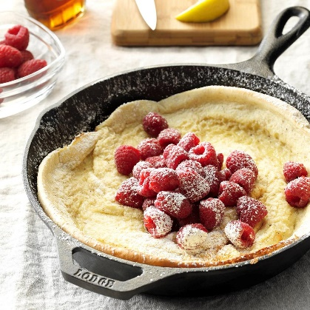

Old-World Puff Pancake
My mom told me her mother-in-law showed her how to make this dish, which became popular during the Depression, on their "get acquainted" visit in 1927. At that time, cooks measured ingredients in pinches, dashes and dibs. But through the years, accurate amounts were noted. My wife and I continue to enjoy this dish today, particularly for brunch. —Auton Miller, Piney Flats, Tennessee

TOTAL TIME: Prep/Total Time: 30 min. YIELD: 4 servings.

Ingredients

2 tablespoons butter

3 large eggs, room temperature

3/4 cup whole milk

3/4 cup all-purpose flour

2 teaspoons sugar

1 teaspoon ground nutmeg

Confectioners' sugar

Lemon wedges

Syrup, optional

Fresh raspberries, optional

Directions

1. Place butter in a 10-in. ovenproof skillet; place in a 425° oven until melted, 2-3 minutes. In a blender, process the eggs, milk, flour, sugar and nutmeg until smooth. Pour into prepared skillet.

2. Bake at 425° until puffed and browned, 16-18 minutes. Dust with confectioners' sugar. Serve with lemon wedges and, if desired, syrup and raspberries.

Salt-Dough Snowflake Ornaments

Courtesy of Better Homes & Garden
A few pantry staples and some snowflake cookie cutters are all you need to create these charming, customizable ornaments. To create, preheat the oven to 200˚F. Mix 1/2 cup salt, 1 cup flour, and 1/2 cup water until it forms a sticky dough. Roll the dough to 1/4 inch thick and use cookie cutters to cut out snowflake shapes. Pierce each shape with a skewer to create a hole for hanging. Bake for 4 hours. Let shapes cool completely. Decorate shapes as desired with a permanent marker.

MIKI DUISTERHOF – Courtesy of Country Living
Road-Map Christmas Gift Wrap
Freebie road maps and atlas pages serve as great graphic gift wrap. Instead of tying a bow on top, thread thin cord through a vintage button and knot tightly to secure.
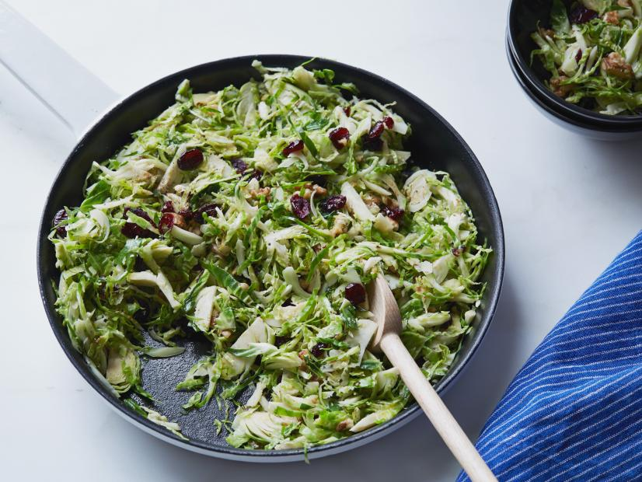

RECIPE COURTESY OF SUNNY ANDERSON

Crunchy Sweet Brussels Sprout Salad
- Total: 18 min
- Prep: 10 min
- Cook: 8 min
- Yield: 4 servings

Ingredients
1 pound Brussels sprouts
2 tablespoons olive oil
1/2 teaspoon ground nutmeg
Kosher salt and freshly ground black pepper
1/2 cup chopped walnuts
1/2 cup dried cranberries

Directions
- Shred the Brussels sprouts by removing the core and thinly slicing.
- Warm the olive oil in a large skillet over medium heat.
- Add the Brussels sprouts, nutmeg, and salt and pepper, to taste.
- Cook, stirring, until the Brussels sprouts are bright and slightly wilted, about 2 to 3 minutes.
- Add the walnuts and the cranberries and toss to combine.
- Turn out into a serving bowl and serve warm.

News from St. Jude

St. Jude and the University of Tennessee Health Science Center begin recruiting adult participants for phase 3 COVID-19 vaccine clinical trial
St. Jude Children’s Research Hospital and the University of Tennessee Health Science Center will offer a testing site for a phase 3 COVID-19 vaccine clinical research study - Memphis, Tennessee, November 13, 2020
St. Jude Children’s Research Hospital and the University of Tennessee Health Science Center will offer a testing site for the Janssen Pharmaceutical Companies of Johnson & Johnson’s Phase 3 clinical research study, ENSEMBLE trial, to evaluate the safety and efficacy of the Janssen’s investigational COVID-19 vaccine candidate, JNJ-78436735, also known as Ad26.COV2.S.
The Phase 3 randomized, double-blind, placebo-controlled clinical trial is designed to evaluate the safety and efficacy of a single vaccine dose of the Janssen COVID-19 vaccine candidate versus placebo, in approximately 60,000 adults 18 years old and older, including significant representation from those that are older than 60.
The trial will include those both with and without co-morbidities associated with an increased risk for progression to severe COVID-19. St. Jude and UTHSC will enroll up to 500 adults aged 18 and older.
ENSEMBLE is being initiated in collaboration with the Assistant Secretary for Preparedness and Response (ASPR), Biomedical Advanced Research and Development Authority (BARDA) and the National Institute of Allergy and Infectious Diseases (NIAID), part of the National Institutes of Health (NIH).
St. Jude is part of the NIAID-supported COVID-19 Prevention Network (CoVPN). The CoVPN is composed of existing NIAID-supported clinical research networks with infectious disease expertise and is designed for rapid and thorough evaluation of vaccine candidates and monoclonal antibodies for the prevention of COVID-19.
The St. Jude Infectious Disease Clinical Research Operations team is closely collaborating with the University of Tennessee Health Science Center’s Office of Clinical Research team and The Department of Internal Medicine Physicians to conduct this study.
Gobble - Gobble!

